**COMSATS University Islamabad, Islamabad campus**

**Department of Computer Science**

**SECOND Sessional Examination, Fall 2020**

**Subjective**

**Class:** BCS/BSE 2  **Marks:** 15

**Subject:** CSC103 Programming Fundamentals  **Time:** 30 min

**Instructors:** Dr. Manzoor Ilahi Tamimy / Mr. Rizwan Rashid / Ms. Saadia Maqbool / Dr. Behjat Zuhaira

**Dated:** December 04, 2020

**Instructions:**

1. Solve all questions on question paper within the space provided.
2. Part – I is form-based and consists of Q – 1, Q – 2, and Q – 3.
3. Part – II consists of Q – 4.

**Q – 4 (CLO – 3) Program/Code (Marks 05+10):**  Write complete Java programs.

1. Get a number, N, from user. Using an infinite loop, display multiplication table of N, as follows:
   * Only even number products should be displayed.
   * The table of N should be displayed for first twenty numbers (from Nx1 to Nx20)

|  |
| --- |
| package com.company;  import java.util.Scanner;  public class question1 {  public static void main (String args[]){  Scanner scan = new Scanner(System.in);  int n;  System.out.println("Enter number for table: ");  n = scan.nextInt();  int i = 1;   while (true){  if ((i*n) % 2 == 0){  System.out.println(n + "*" + i + "="+n*i);  }  if (i == 20){  break;   }  i++;  }   } } |

1. Write a program that takes two 1D arrays from the user and combines them into one 1D array.
   * Create two 1D arrays of integers, array_1 and array_2, of size N and M respectively. N and M are given by the user.
   * Assign values to array_1 and array_2 by taking values from the user.
   * Pass both arrays to a method, combine() that creates and returns a 1D array by combining array_1 and array_2, as shown in the figure below.
   * Display contents of the combined array in main().

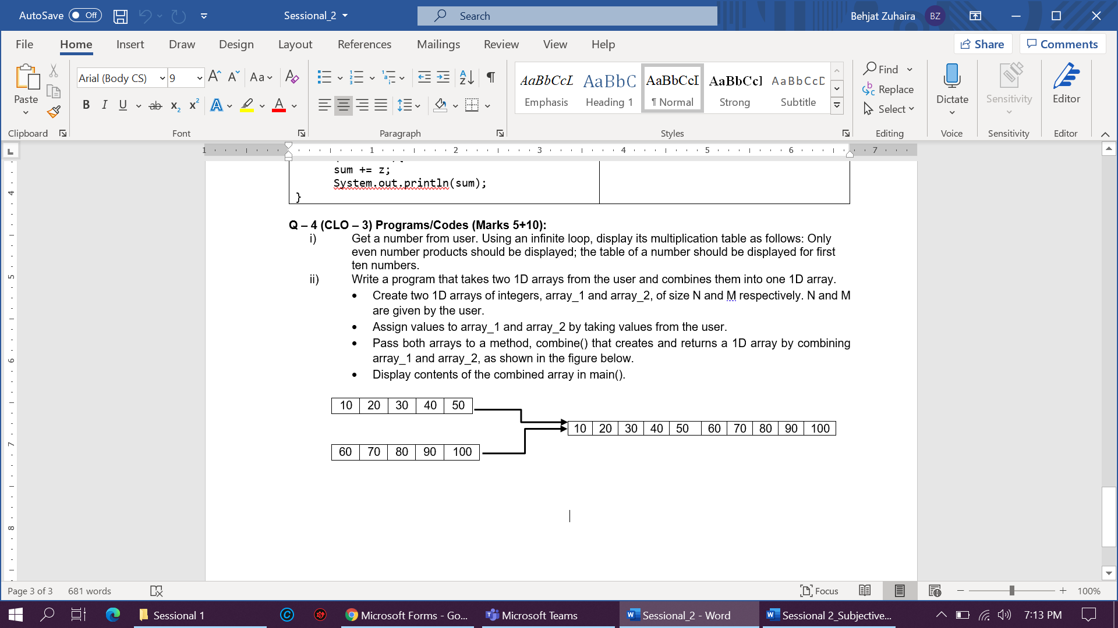

|  |
| --- |
| package com.company;  import java.util.Scanner;  public class array {  public static void main (String args[]){  Scanner scan = new Scanner(System.in);  int N, M;  System.out.println("Enter Length of Array 1: ");  N = scan.nextInt();  System.out.println("Enter Length of Array 2: ");  M = scan.nextInt();  int[] array_1 = new int[N];  int[] array_2 = new int[M];  int[] array_3 = new int[N+M];   for (int i=0; i< array_1.length; i++){  System.out.println("Enter number of array 1 at location:" + i);  array_1[i] = scan.nextInt();  }   for (int i=0; i< array_2.length; i++){  System.out.println("Enter number of array 2 at location:" + i);  array_2[i] = scan.nextInt();  }  array_3 = combine(array_1,array_2);  for (int k = 0 ;k< array_3.length;k++){  System.out.print(" " + array_3[k]);  }   }   public static int[] combine(int[] a1,int[] a2){  int n = a1.length + a2.length;  int[] result = new int[n];  for (int i=0; i< a1.length;i++){  result[i] = a1[i];   }  int k = 0;  for (int j= n-a1.length ; j< result.length; j++){   result[j] = a2[k];  k++;  }   return result;    } } |